Mr. Simpson PHHS Physics 1, 2 (NGSS: "Physics of the Universe" (newest title))
Room 408
gsimpson@sandi.net 2024-2025 Phone: 619.286-7700 ext.2408

EMAIL IS THE BEST WAY TO CONTACT ME. **ALWAYS INCLUDE STUDENT’S FIRST NAME, LAST NAME, & PERIOD IN THE SUBJECT LINE OF THE EMAIL.

Welcome to Physics! This course covers most of the state of California content standards for physics, check them out here: State of California Department of Education. (Really, check them out! It is fun to see what science concepts were taught at different grade levels.) We have adopted the Next Generation Science Standards (NGSS). These standards blend concepts typically considered earth science/space science and engineering, with physics. You will engage in the Science and Engineering Practices (SEP) as well as the Crosscutting Concepts (CCC) to explore phenomena demonstrating the Disciplinary Core Ideas (DCI) of each instructional segment. The eight practices of science and engineering that the NGSS Framework identifies as essential for all students to learn are listed below:

1. Asking questions (for science) and defining problems (for engineering)
2. Developing and using models
3. Planning and carrying out investigations
4. Analyzing and interpreting data
5. Using mathematics and computational thinking
6. Constructing explanations (for science) and designing solutions (for engineering)
7. Engaging in argument from evidence
8. Obtaining, evaluating, and communicating information

NGSS supports California’s Common Core State Standards for Math; and English Language Arts, Literacy in History/Social Studies, Science, and Technical Subjects.

CA NGSS “Physics of the Universe”

SDUSD (2021-2022) Physics, Theme: Systems and Power

Physics Priority Performance Expectations (PPE)

You will be using Conceptual Physics by Paul Hewitt (3rd edition). This excellent textbook provides straight-forward explanations of physics topics without a lot of math – the Conceptual Method pioneered by Paul Hewitt. Stressing concepts first and then computations. Great Paul Hewitt CP Resources: Conceptual Physics Academy and Conceptual Physics Problems & Solutions

The course will cover all of the following NGSS topics in a logical sequence:

Concepts | What We Learn
Science Fundamentals | Lab Safety, Metric Review, About Science, Sci. Method vs. Eng. Method (NGSS)
Forces and Motion | Kinematics: Distance, Time, Speed, Average Speed, Velocity, and Acceleration in Hor. & Vert. Planes, (NGSS: Plate Tectonics),  Projectile Motion, Newton’s Laws, Friction, Free-body Diagrams, Momentum, Impulse, Collisions and Conservation of Momentum
Forces at a Distance | Centripetal Motion, Circular Acceleration and Velocity, Gravity (NULOG), Mass vs Weight, Electrostatic Forces, Magnetism, and Kepler’s Laws (NGSS: Celestial Movement), Quick Hist. of Modern Sci./Astronomy/Physics (Aristotle to Einstein), The Solar System
Energy Conversion | Work, Power, Kinetic Energy, Potential Energy, Sources of Energy, Renewable vs Nonrenewable Energy, Motors, Generators, and Energy Transformations
Nuclear Processes | Charge, Electricity Generation, Current, Ohm’s Law, Circuits, Nuclear Energy, Fission, Fusion, Radioactive Decay, Radiometric Dating, and Power (NGSS: Nuclear Processes)
Waves and Electromagnetic Radiation | Energy Transfer, Properties of Waves, Sound, Doppler Effect, and EM Spectrum, Light and Wave Phenomenon
Stars and the Origin of the Universe | Big Bang Theory, Kepler's Laws, Relativity (Einstein), Orbital Motion, the Sun & Stellar Evolution (NGSS: the Sun and Stellar Lifecycles)

Course Requirements

It is important to attend classes prepared to take notes, participate in discussions and practice mathematical calculations. Please bring a physics notebook to class every day. You will need to be able to perform calculations with numbers in scientific notation. A handheld scientific calculator is the easiest way to solve math problems, but there are scientific calculators available online. It is not necessary to buy an expensive graphing calculator. All calculators need to be able to is handle is scientific notation and trigonometric functions (sine, cosine and tangent). These calculators are typically under $15. This type of calculator can be used in most science classes for your entire academic career. If you purchase one now you will be very familiar with it by the time you graduate, ready for college, but you do not need to purchase one for this class. You can check out calculators from the library.

School supplies are available. A limited number of scientific calculators can be checked out from the library. Please do not check out the graphing calculators unless your math teacher requires one.

Pencil, pen, scientific calculator, ruler, and protractor are all commonly used throughout the school year. These are basic tools needed.

Homework is rarely due within 48 hours. Assignment list usually gives due dates. We update the assignment list often. This gives you time to attempt the assignment and ask questions during class and office hours. Please ask questions! Homework is for practice. This is a problem-solving class. You need to practice solving problems. You need to practice thinking about how to solve problems. Homework is not intended to stress you out or take hours. Start it early and ask thoughtful questions. Analogy: Think of HW like the work you have to do at a daily job. Payday is when you take the test. You got to do the job to get the paycheck! Another analogy: HW is like doing push-ups. You have to do the push-ups and practice and train (i.e. all the classwork and homework) to be able to be ready for the fitness test (the day of an exam). Homework must be neat, complete and organized. Please advocate for yourself if you need additional time to complete an assignment or test. If you have an IEP or 504 plan and you will know this, sometimes I forget, please remind me. Please communicate your needs. I want to be fair, compassionate and ethical about facilitating this class.

Grading (since 2021/2022 now Standards Based Grading):

Your class percentage is calculated as follows:

Formative assessments (quizzes): 0%

Summative assessments (Tests 80%, projects, student files 20%): 100%

Classwork/Homework: 0% (Student work/Homework goes into a summative student file)

49066
Title 5

ASSIGNMENT LIST: You will maintain an assignment list indicating the date the assignment was given, the due date, the title of the assignment, and specific instructions for the assignment. Parents, the best way to oversee your student's classwork and to know what homework is required and when it is due is to request from your student their assignment list on a daily basis and to also check the website for instructions.

You need to keep all your work in a file/folder until your grade is finalized. Student work is scored using a file/folder system. You will learn this system – it’s great! Many students are very successful utilizing this fair and accountable system. You will keep all 4 files until the end of the school year (very important to do so – study guides for finals).

More on grades:
You are welcome to dispute my data input errors, as long as you have your work as proof. Please check your grades regularly. The District maintains Powerschool and the server.

GRADING SCALE: 90-100% = A 80-89% = B 70-79% = C 60-69% = D 0-59% = F
(0 – 5 grading scale is being used. See poster in classroom. Same scale as used in the Chemistry department.)

SEMESTER GRADE: The semester grade will be based on a cumulative total from the entire semester. In other words, your points divided by the total points possible X 100 = ___%. The same grading scale will be used as mentioned previously.

SIGNIFICANT CHANGE TO LATE WORK AND RE-TAKING TESTS: (November 2, 2020)

Acceptance of late work will not be reduced in value: Your Student Files have traditionally reduced the value for late work from 100% (if complete and reviewed and turned in on time) to 70%. Now Student files will have the following percentages for student work/HW: 100% (if complete and reviewed and turned-in by the final due date for the entire file). There are still due dates for individual assignments. There is the initial due date for the assignment. You should stay on this schedule so you do not fall behind. However, if you do not make this initial due date, your assignment will not be reduced in value for not making this initial due date. 40% (for work incomplete but at least half completed), 0% (for work less than half completed or not turned in at all). The ultimate due date for the entire Student Files to be turned in, will be maintained and abided by. Student files which include all your classwork/home-works are a part of the overall summative assessment and account for and are weighted as 20% of your overall grade.

Re-taking tests: is allowed if you have received a C, D, or F on the exam only. Only one re-take opportunity will be allowed per semester. The highest score will be the accepted score. These re-takes will be taken at the same time when other students must make-up tests that they have missed for legitimate absences.

Citizenship: has always regarded behavior only, never associated with your academic grade. However, now turning in late HW can be regarded as a behavior and can reduce your citizenship score. Keep that in mind.

Absences for religious or cultural holiday observance, excused absences and excused tardies shall not be factored into the citizenship grade. Grades assigned for citizenship, shall be reported as follows:

Citizenship Grade | Expectation
Exceeds (E) | Consistently exceeds expectations in work completion, preparation, and participation, and actively contributes to the learning experiences of their peers.
Meets (M) | Consistently meets expectations: completes work on time, prepared to learn, participates regularly, shows respect for others, and contributes to building a positive community.
Inconsistent (I) | Inconsistently meets expectations: occasionally completes work on time, not always prepared to learn, participates irregularly, and rarely works well with others.
Unsatisfactory (U) | Does not meet expectations: work is habitually late, not prepared to learn, does not participate, and does not work well with others.

You should expect an M, unless you are actively contributing and enriching the class. Citizenship marks are recorded on a student’s cumulative grade history but are not reported on transcripts. They do determine some eligibility for school activities. Any instance of academic dishonesty would override all of the above descriptors for determining citizenship.
School-wide Citizenship Expectations

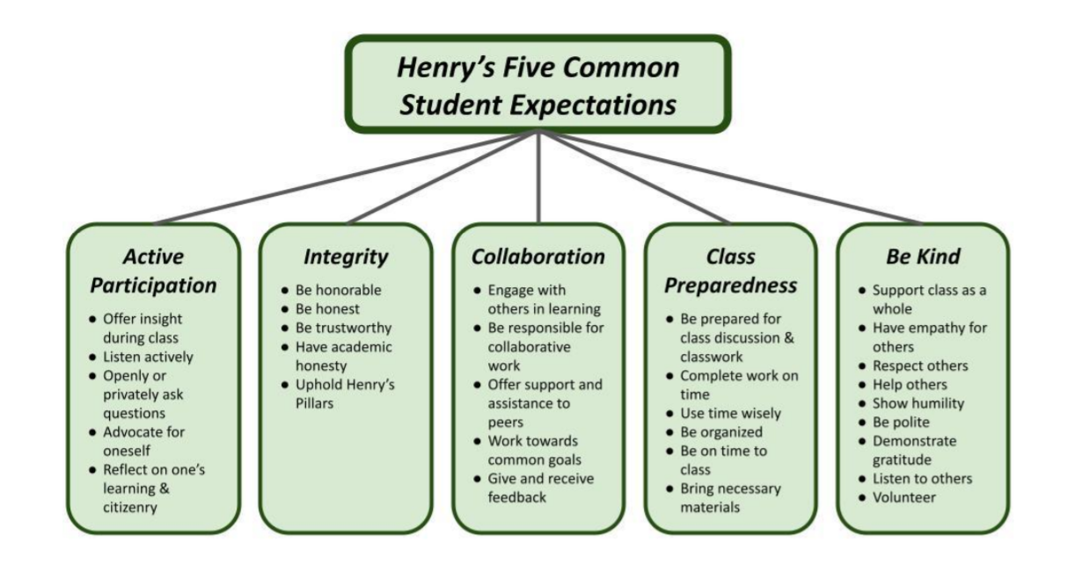

Bathroom Passes: you have 4 bathroom passes per semester. Save them. Go to the bathroom on your time. Take care of business. Be responsible. Being responsible is rewarding. Time out of class disrupts the teaching and learning process. Going over 4 BR passes per semester can result in a “U” for citizenship. The BR pass policy doesn’t apply to students on a 504 or students with special BR needs as required.

--------------------------------------------------------------------------------------------------------------------------------------------

Sign and place into your file/folder by due date: __________________

I have read and understand the Academic and On-line Classroom Behavior Plan for Mr. Simpson's Physics class. (School Year 2024/2025)

Print name of student________________________________ Class period_____

Signature of student_________________________________ Date___________

Print name of parent or guardian_______________________________________

Signature of parent or guardian________________________________________

